**Final keyword**-

It is keyword which is applied to variables, method and class.

**When to use final keyword ?**

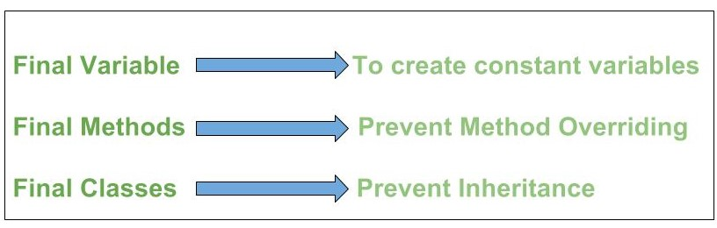

**Final variable-**

A variable which is declared with final keyword called as final variables.

Once you assigned any value to that variables then it won’t be changed.

It works like constants in java.

**How to declare the final variables**-

**final** **int** a=5;

Example-1

**package** com.test;

**public** **class** FinalDemo {

**public** **static** **void** main(String[] args) {

**final** **int** a = 5;

System.***out***.println(a);

}

}

Output-

5

Example-2

**package** com.test;

**public** **class** FinalDemo {

**public** **static** **void** main(String[] args) {

**final** **int** a = 5;

a++;

System.***out***.println(a);

}

}

In this example, we will get compile time error, final variable values does not changed.

**Final method-**

Method which is defined with final keyword called as final method.

**How to declare the final method-**

**public** **final** **void** m1() {

//business logic here

}

Note-

1. Final method cannot be overridden.

Example-1

**package** com.test;

**public** **class** X {

**public** **final** **void** x1() {

System.***out***.println("Class X- x1 method...");

}

}

**package** com.test;

**public** **class** Y **extends** X {

**public** **final** **void** x1() {

System.***out***.println("Class Y-x1 method..");

}

**public** **static** **void** main(String[] args) {

Y y=**new** Y();

y.x1();

}

}

Output-

Nothing

In this example, we will get compile time error final method cannot be override final method from X

**Final class-**

The class which is defined with final keyword called as final class.

**How to declare the final class**

**package** com.test;

**public** **final** **class** Y {

}

Note- How you stop others from inheriting your class-

                        By making class as final.

**package** com.test;

**public** **final** **class** X {

}

**package** com.test;

**public** **class** Y **extends** X {

}